By Henok Teka

Steps

If previously created, cleanup cluster with

Get-Cluster -Name SQLFCIDNSVNN | Remove-Cluster -Force -CleanupAD

Same subnet 10.4.1.0/24

1. Created VMs with ip, dns and changed the dynamic ip to static
2. Registered the DC ip with DNS

(I added the HA nodes’ IPs to DC DNS, but this is not needed when I recreate later. It even caused a problem and showed lots of ip for dns server when I check with ipconfig /all). The Ip of the DC is in DC’s DNS (I could be wrong.)

1. Used powershell command to create cluster

New-Cluster -Name oltpprod -Node FCINODE1, FCINODE2 -StaticAddress 10.4.1.9 -NoStorage -AdministrativeAccessPoint ActiveDirectoryAndDns -ManagementPointNetworkType Singleton

1. Added shared disks in the portal
2. **Initialize** disks with GPT – from one node is enough. No further action needed – ONLY INITIALIZE.

1. Added the disks to the cluster

1. Label/format the disks (go back to nodes and “new simple volume” and give Letter)

Before you do this put the cluster disk (shown above) “Under maintenance” otherwise it will throw error (not formatted error). Turn maintenance mode off after finishing formatting.

1. Create quorem

Add the disk that is assigned as a witness disk.

1. Create ILB
2. Install sql

In network name I gave “SQLFCIVNN”

Default

Since I added disk2 as witness quorem

Uncheck DHCP, check ipv4 and provide IP

The right permission

Directories

Finish the set up and ADD NODE on the second HA node.

Check dependencies

1. Testing

After configuring the listener, I tested without applying the VNN load balancer listner. It failed to work.

But after running the VNN listener creating script, it worked and I can connect from other nodes. Information ($ClusterNetworkName, $IPResourceName and $ILBIP) to be included in the listener PowerShell script can be found from the pictures below. [int]$ProbePort can be found from the load balancer.

Get-ClusterResource $IPResourceName | Get-ClusterParameter --to get cluster info

[Configure an Azure load balancer for an AG VNN listener - SQL Server on Azure VMs | Microsoft Learn](https://learn.microsoft.com/en-us/azure/azure-sql/virtual-machines/windows/availability-group-vnn-azure-load-balancer-configure?view=azuresql&tabs=ilb)

$ClusterNetworkName = "Cluster Network 1"

$IPResourceName = "SQL IP Address 1 (SQLFCIVNN)"

$ILBIP = "10.4.1.25"

[int]$ProbePort = 59999

Import-Module FailoverClusters

Get-ClusterResource $IPResourceName | Set-ClusterParameter -Multiple @{"Address"="$ILBIP";"ProbePort"=$ProbePort;"SubnetMask"="255.255.255.255";"Network"="$ClusterNetworkName";"EnableDhcp"=0}

* After you run the command take the listener (SQLFCIVNN) “offline” then online and make sure everything is online.

Get the information from cluster see below.

SQLFCIVNN.hgtd.com

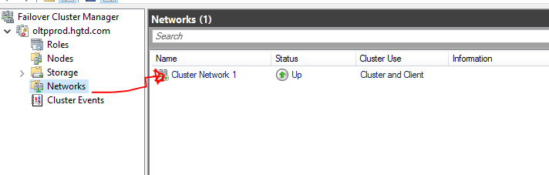

Run select @@servername to check

FOR AG, you enable always on and create AG (e.g. AGCLU), then create “client access point” **another name for Listener** on it, and on the AGCLU create dependency and mention the listener’s name. The create load balancer and use the same script above to use powershell.

Testing VNN with distributed server name

Destroyed the previous nodes.

Created new cluster…steps are the same. This time it is created with Distributed server name.

Testing connection

* Without VNN listener configuration: it didn’t work as expected
* With VNN PowerShell script:

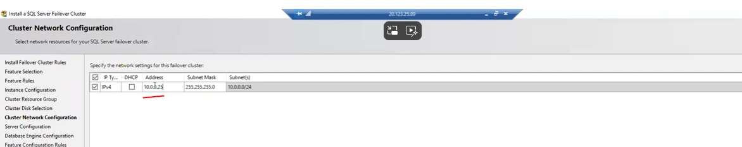

For latest version (2019) window , DNN works for FCI

